**Programming Lab 3**

**Practical N0. 2**

**Name: Trishul Balaso Patil**

**PRN : 22510051**

**Batch: T5**

**Topic: Study of HTML and CSS.**

Create a website which displays the course information using static web pages

**Problem Statement 1: Basic HTML**

**Create a HTML file named "course.html" with a proper document structure.**

**Add a title to the webpage: "Introduction to [Your Course Name] Course".**

**Create a header section with the course name as the main heading and a brief**

**description as a subheading.**

**Design a navigation menu with links to different sections of the page: "About the**

**Course," "Course Outline," and "Instructors." (For this you may create separate**

**pages and link them or you can create it on single page. But when you click on the**

**navigation menu only those particular contents will be displayed)**

<!DOCTYPE html>

<html lang="en">

<head>

<meta charset="UTF-8">

<meta name="viewport" content="width=device-width, initial-scale=1.0">

<title>Introduction to Cybersecurity Course</title>

<link rel="stylesheet" href="style.css">

</head>

<body>

<header>

<h1>Introduction to Cybersecurity Course</h1>

<p>Protecting Digital Information in the Modern World</p>

</header>

<nav>

<div class="menu-icon" onclick="toggleMenu()">☰</div>

<ul class="nav-links">

<li><a href="course.html#about">About the Course</a></li>

<li><a href="course-outline.html">Course Outline</a></li>

<li><a href="instructors.html">Instructors</a></li>

</ul>

</nav>

<section id="about" class="active">

<h2 id="aboutCourse">About the Course :</h2>

<p>

The "Introduction to Cybersecurity" course is designed to provide learners with a comprehensive understanding of the fundamental principles and practices in cybersecurity. This course aims to equip students with the knowledge and skills necessary to protect networks, data, and systems from various cyber threats.

</p>

<p id="obj"><strong>Objectives:</strong></p>

<ul id="objective">

<li>Understand the basic concepts of cybersecurity and its importance in the digital age.</li>

<li>Learn about different types of cyber threats and how to defend against them.</li>

<li>Gain knowledge in network security, cryptography, and incident response.</li>

<li>Develop practical skills in securing digital information and infrastructure.</li>

<li>Prepare for advanced studies or careers in cybersecurity.</li>

</ul>

<p><strong>Target Audience:</strong> This course is ideal for beginners who are interested in pursuing a career in cybersecurity, IT professionals looking to enhance their security knowledge, and anyone who wants to learn how to protect their digital assets.</p>

</section>

<footer>

<p>&copy; 2024 Introduction to Cybersecurity Course. All rights reserved.</p>

</footer>

</body>

</html>

**Problem Statement 2: Styling with CSS**

**Create a separate CSS file named "styles.css" and link it to the "course.html" file.**

**Style the header section with a background colour, white text colour, and proper**

**padding.**

**Apply a font-family of your choice to the entire document.**

**Add a background colour to the navigation menu items when hovered over.**

**Style the course description text with a distinctive font style and colour.**

**Create a two-column layout for the "About the Course" and "Course Outline"**

**sections using CSS Grid or Flexbox.**

**Apply a box-shadow to the instructor cards in the "Instructors" section.**

**Style the footer with a dark background colour, light text colour, and centred**

**content.**

body {

*margin*: 0;

*padding*: 0;

*line-height*: 1.6;

}

header {

*background-color*: #f39b16;

*color*: white;

*padding*: 20px 0;

*text-align*: center;

}

header h1 {

*margin*: 0;

*font-size*: 2.5em;

}

header p {

*margin*: 5px 0 0;

*font-size*: 1.2em;

*font-style*: italic;

}

nav {

*background-color*: #444;

*padding*: 10px;

*position*: relative;

}

.nav-links {

*list-style-type*: none;

*padding*: 0;

*margin*: 0;

*display*: flex;

*justify-content*: center;

*flex-wrap*: wrap;

}

nav ul li {

*margin*: 0 15px;

}

nav ul li a {

*color*: white;

*text-decoration*: none;

*font-weight*: bold;

*cursor*: pointer;

}

nav ul li a:hover {

*background-color*: #555;

*padding*: 5px 10px;

*border-radius*: 5px;

}

.menu-icon {

*display*: none;

*font-size*: 2em;

*color*: white;

*position*: absolute;

*top*: 10px;

*right*: 20px;

*cursor*: pointer;

}

@media screen and (*max-width*: 768px) {

.nav-links {

*display*: none;

*flex-direction*: column;

*text-align*: center;

*width*: 100%;

*position*: absolute;

*top*: 50px;

*left*: 0;

*background-color*: #444;

}

.nav-links.active {

*display*: flex;

}

.menu-icon {

*display*: block;

}

}

section {

*padding*: 20px;

}

#about, #course-outline {

*display*: grid;

*justify-content*: space-around;

*grid-template-columns*: 1fr 1fr;

*gap*: 20px;

}

@media screen and (*max-width*: 768px) {

#about, #course-outline {

*grid-template-columns*: 1fr;

}

}

#about p, #course-outline p {

*color*: #666;

*font-style*: italic;

}

#course-outline h2{

*margin-left*: 30px;

}

#course-outline ol{

*margin-right*: 500px;

*width*: 500px;

*margin-top*: 100px;

}

#aboutCourse{

*margin-left*: 200px;

}

#obj{

*margin-left*: 200px;

}

#objective{

*margin-right*: 400px;

*width*: 400px;

}

#instructors {

/* display: grid; */

/* grid-template-columns: 1fr 1fr 1fr; */

/* gap: 20px; */

}

.instructions_container {

*display*: flex;

*gap*: 30px;

*width*: 100%;

}

@media screen and (*max-width*: 768px) {

#instructors {

*grid-template-columns*: 1fr;

}

}

.instructor {

*background-color*: #f4f4f4;

/* display: flex; */

*padding*: 15px;

*border-radius*: 5px;

*box-shadow*: 0 4px 8px rgba(0, 0, 0, 0.2);

*margin-top*: 50px;

}

.instructor-photo {

*margin-left*: 70px;

*width*: 300px;

*height*: 300px;

*border-radius*: 5px;

}

.instructor:hover{

*box-shadow*: 0 4px 8px rgba(0, 0, 0, 0.3);

}

#instructors h2 {

*margin-top*: 0;

}

footer {

*background-color*: #a1fcf9;

*height*: 20px;

*color*: rgb(208, 202, 202);

*display*: flex;

*justify-content*: center;

*align-items*: center;

*padding*: 10px 0;

*text-align*: center;

}

**Problem Statement 3: Course Content Display**

**In the "About the Course" section, provide a detailed description of the course,**

**including its objectives and target audience.**

**Create an ordered or unordered list in the "Course Outline" section, outlining at**

**least Six modules/topics covered in the course.**

**Display instructor information in the "Instructors" section, including their names,**

**photos, and a brief bio.**

<!DOCTYPE html>

<html lang="en">

<head>

<meta charset="UTF-8">

<meta name="viewport" content="width=device-width, initial-scale=1.0">

<title>Course Outline - Introduction to Cybersecurity</title>

<link rel="stylesheet" href="style.css">

</head>

<body>

<header>

<h1>Introduction to Cybersecurity Course</h1>

<p>Course Outline</p>

</header>

<nav>

<div class="menu-icon" onclick="toggleMenu()">☰</div>

<ul class="nav-links">

<li><a href="course.html#about">About the Course</a></li>

<li><a href="course-outline.html">Course Outline</a></li>

<li><a href="instructors.html">Instructors</a></li>

</ul>

</nav>

<section id="course-outline" class="active">

<h2>Course Outline</h2>

<ol>

<li><strong>Introduction to Cybersecurity:</strong> Understanding the need for cybersecurity and its impact on the digital world.</li>

<li><strong>Threats and Vulnerabilities:</strong> Exploring various types of cyber threats, including malware, phishing, and social engineering.</li>

<li><strong>Network Security:</strong> Learning about firewalls, intrusion detection systems, and network defense strategies.</li>

<li><strong>Cryptography:</strong> Introduction to encryption, decryption, and secure communication techniques.</li>

<li><strong>Application Security:</strong> Understanding how to secure software applications and protect against common vulnerabilities.</li>

<li><strong>Incident Response and Recovery:</strong> Developing a plan to respond to and recover from cybersecurity incidents.</li>

</ol>

</section>

<footer>

<p>&copy; 2024 Introduction to Cybersecurity Course. All rights reserved.</p>

</footer>

</body>

</html>

**Problem Statement 4: Responsive Design**

**Implement responsive design techniques to make the website mobile-friendly.**

**Ensure that the navigation menu collapses into a hamburger menu on smaller**

**screens.**

**Adjust the layout and font sizes for optimal viewing on various devices.**

*function* toggleMenu() {

*const* navLinks = document.querySelector('.nav-links');

navLinks.classList.toggle('active');

}

*function* showSection(*sectionId*) {

*const* sections = document.querySelectorAll('section');

sections.forEach(*section* *=>* {

*section*.classList.remove('active');

});

document.getElementById(*sectionId*).classList.add('active');

}

window.onload = *function* () {

showSection('about');

}

ScreenShots of the WebPage :

About the Course :

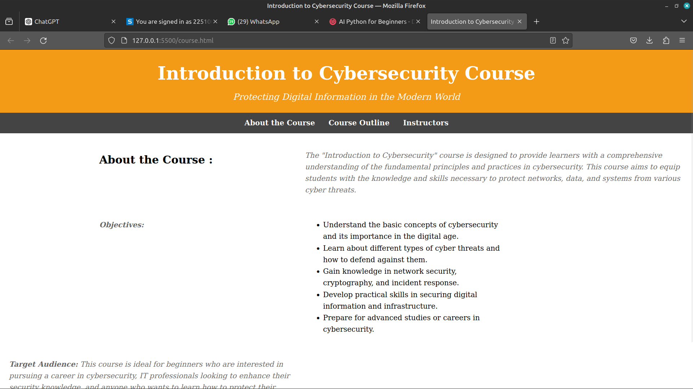

Course Outline :

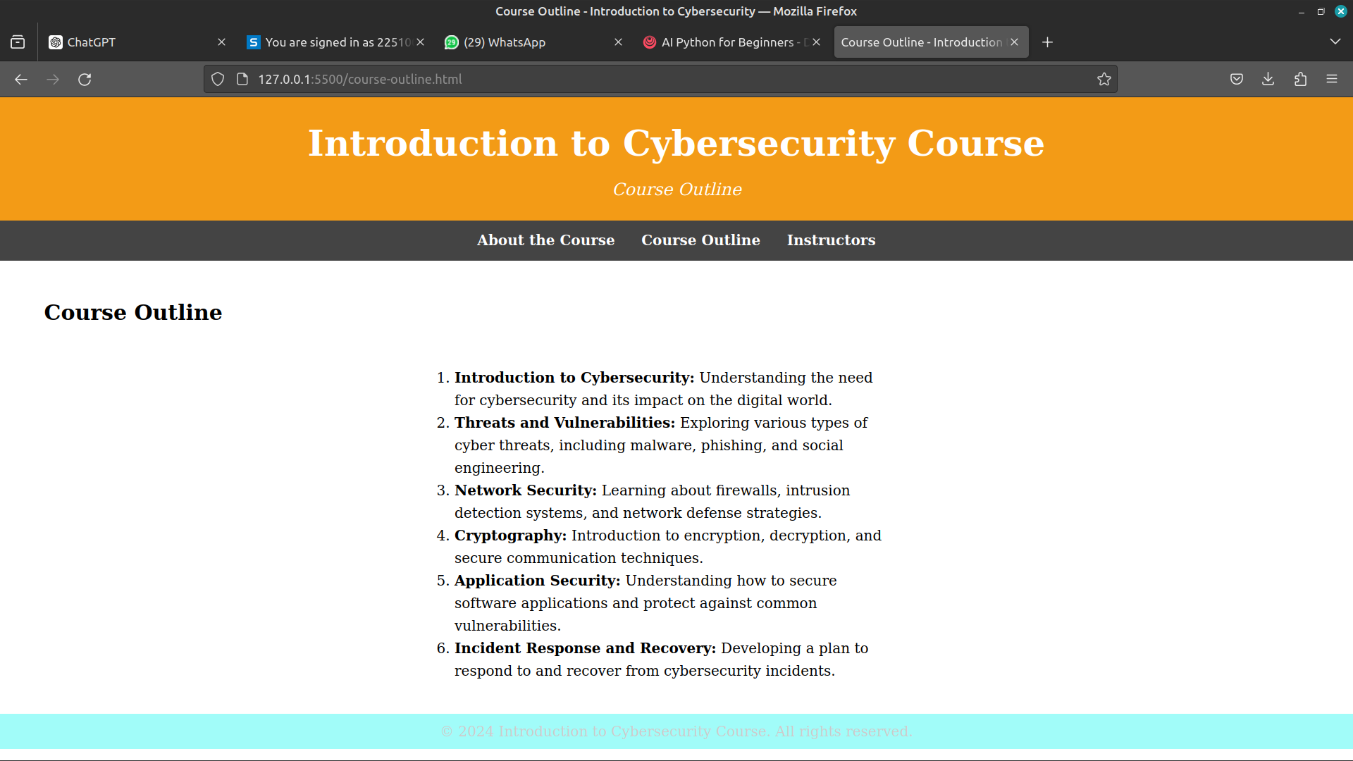

Instructors :

